CLEAN-UP EXERCISE AT BAWJIASE IN THE AWUTU SENYA DISTRICT
On Saturday, 5th July 2025, the Awutu Senya District Assembly in collaboration with the MP for Awutu Senya West and the Deputy Minister of Works and Housing Hon. Gizella Tetteh-Agbotui organized a massive clean-up exercise at Bawjiase to desilt gutters and clear both solid and liquid waste at the main Bawjiase market, lorry station and other surrounding areas.
This exercise aligns with President Mahama’s announcement on the revival of the National Sanitation Day programme as a legally backed initiative to tackle Ghana’s sanitation challenges and promote cleaner environment.
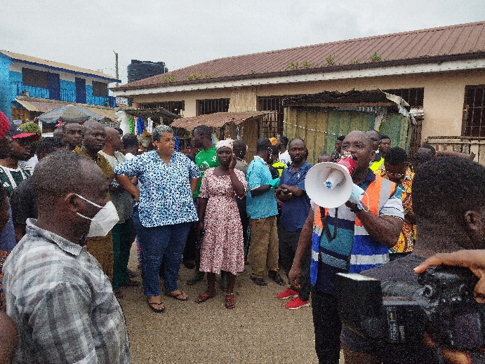
Speaking to the media and the people after the over four-hour clean-up exercise, the DCE Hon. Nyamekye Kalala Eghan commended the people for their active participation in the exercise especially the MP, the chief of Bawjiase, the Assembly staff and all the stakeholders who contributed in diverse ways.
The DCE further stated that the exercise which was the second edition since he assumed office is not going to be a ‘one-day show’ but rather a continues one which would be held ones in every month. He therefore encouraged the people to embrace cleanliness as a routine practice.
“The Assembly together with the MP is going to provide the community with tools that can be used to sustained the monthly clean-up activities towards promoting a clean environment and a healthy life”. The DCE added.
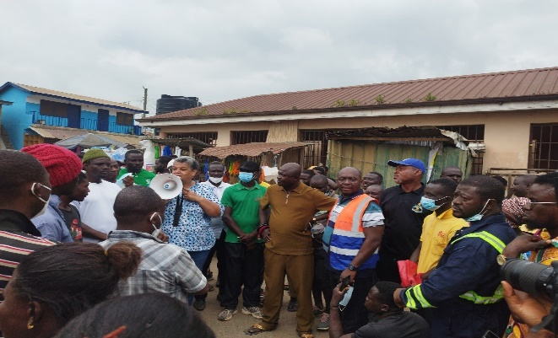
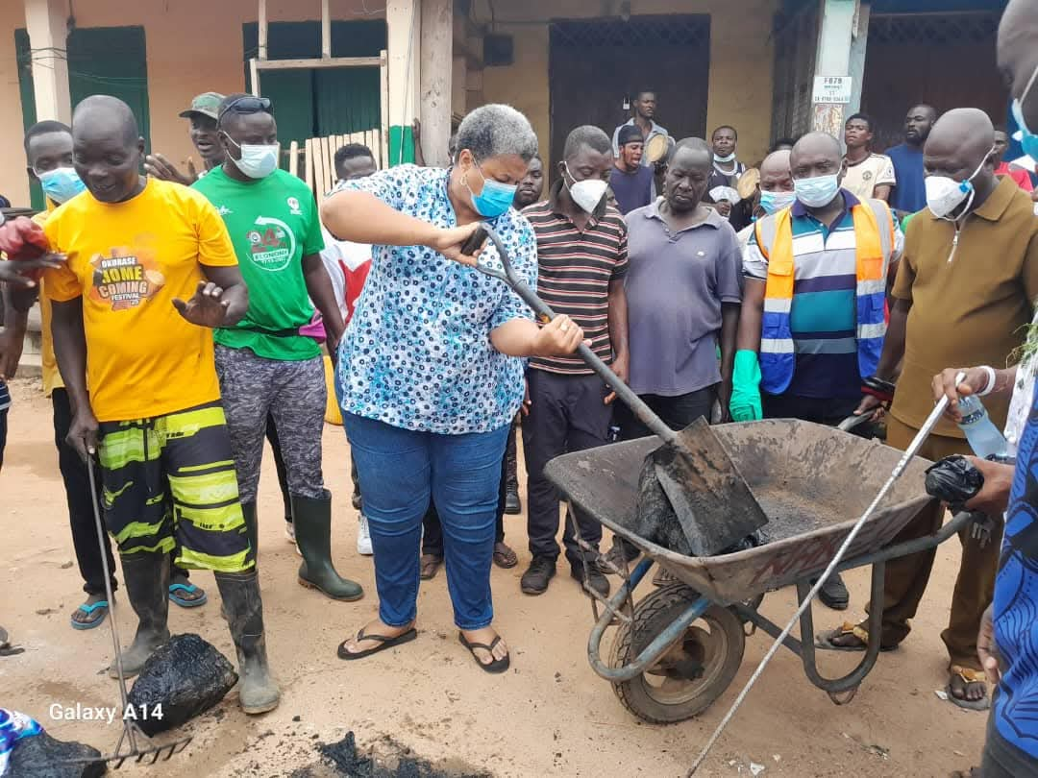
For her part, MP for the constituency Hon. Gizella Tetteh-Agbotui stated that sanitation is a shared responsibility and for that matter reminded the people to be responsible in the way they dispose their waste and its management.

Hon. Gizella further disclosed that in the month of August 2025, a sod would be cut for the construction of a contemporary market square at Bawjiase. which comprises of all the component in a modern market at Bawjias, and would operate 24 hours none stop.
The Omanhene of Bawjiase, Nai Osardu III appreciated the MP and the District Assembly for their decision to bring the exercise to Bawjiase. He promised to ensure that the exercise is sustained to conscientize the people about personal hygiene and clean environment.
Additional Pictures from the exercise.
