SITE INSPECTION BY THE DCE, HON. KALALA EGHAN

REPORT BY ISD
On the 15th July, 2025 Tuesday, the District Chief Executive of Awutu Senya District Assembly, Hon. Nyamekye Kilala Eghan together with Presiding Member and some technical officers from the Assembly embarked on a site inspection exercise on some sites for proposed projects across the district as well some existing uncompleted projects within the district which needs urgent attention.
The sites visited include a proposed site for CHPS Compound and Market at Akrampah, DCE Bungalow also at Akrampah, Teachers quarters at Beraku, Beraku Market all at Beraku. He also inspected the state of the Beraku to Bontrase road which is in a deplorable state. Agenda 111 site at Small London. A proposed school site at Bosomabena. A proposed school and market site at Loye.
Also, he visited the Awutu Bentum school, Bawjiase Islamic school as well as the Oklu-Nkwanta CHPS Compound.
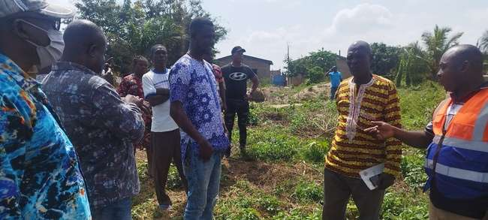

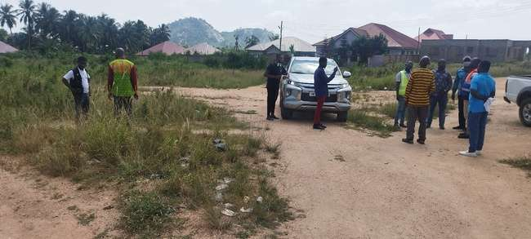
Proposed site for CHPS Compound at Akrampah

Proposed site for Market at Akrampah

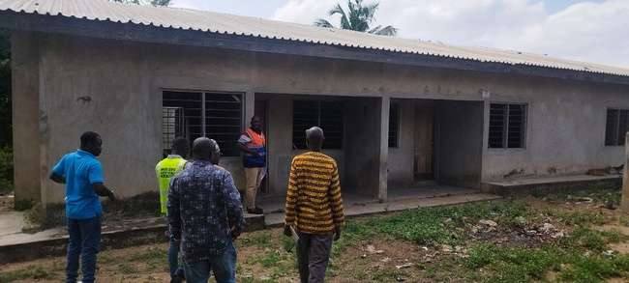

Teachers’ quarters at Beraku
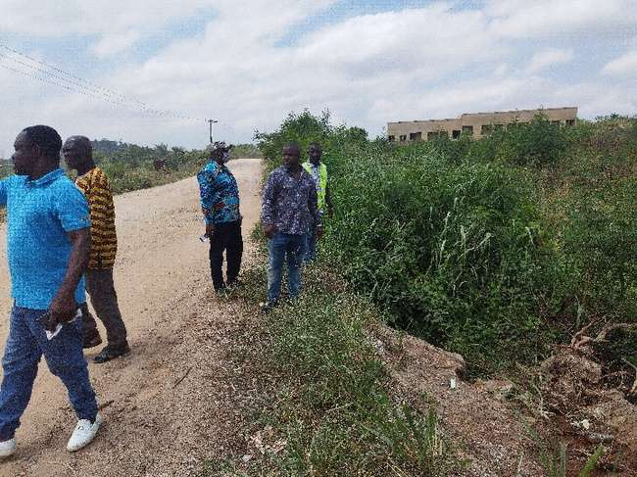
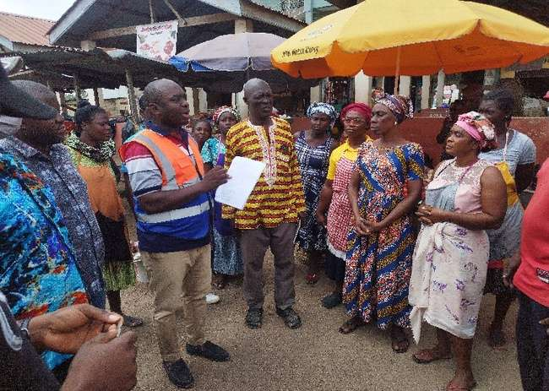

DCE Engages with Market women at Beraku Market Inspection of the Bontrase – Beraku Road
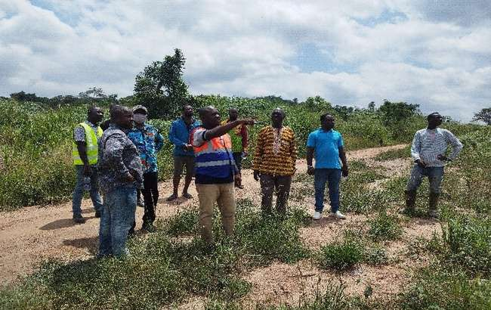
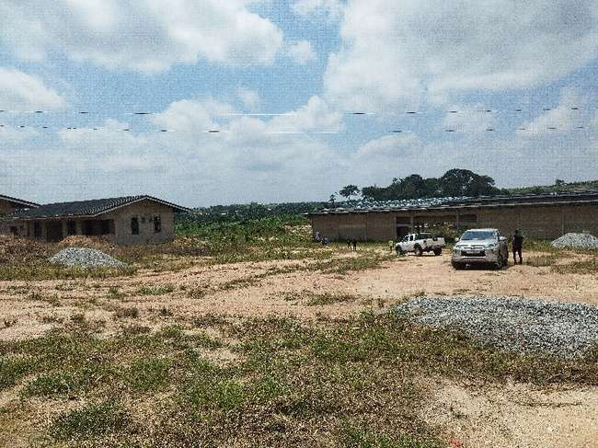

Inspection of Agenda 111 site Inspection of proposed school site at Bosomabena

