REPORT ON DISTRIBUTION OF WORKING TOOLS TO PERSONS WITH DISABILITY BY THE AWUTU SENYA DISTRICT ASSEMBLY
Date of Event: 15th November, 2023
Venue: Forecourt of the Awutu Senya District Assembly

1. INTRODUCTION
On Wednesday, 15th November 2023, the Awutu Senya District Assembly organized a special event at the forecourt of the Assembly to distribute working tools to selected Persons With Disability (PWDs) across the district. This initiative was part of the government’s broader commitment to empowering persons with disabilities through skills development and income-generating support.

2. OBJECTIVE OF THE DISTRIBUTION
The primary goal of the distribution was to provide essential tools to PWDs to help them become more self-reliant, economically active, and integrated into mainstream society. The support is in line with national disability empowerment policies and the Disability Fund initiatives managed through the District Assemblies.

3. ITEMS DISTRIBUTED
A total of eighty (80) registered PWDs benefited from the program. Each beneficiary received one of the following items:
- 40 Singer Hand Sewing Machines
- 40 Igloo Ice Chests (20 Litres Capacity)
These items were carefully selected based on the skill sets and economic activities of the beneficiaries, ranging from tailoring to small-scale cold storage and beverage sales.

4. GENDER DISTRIBUTION
The distribution was done equitably to ensure gender balance:
- 40 Female Beneficiaries
- 40 Male Beneficiaries

5. COMMUNITIES REPRESENTED
Beneficiaries were drawn from various communities within the Awutu Senya District, including:
- Ayensuako
- Senya
- Bewuenum
- Ofada
- Ofadjator
- Bereku
- Bawjiase
- Ofaso

6. Names of Beneficiaries
Below is the list of the 80 beneficiaries who received the working tools:
- Samuel Agyina
- Emelia Otoo
- Lincoln Akrashe
- Oppong Stephen
- Rebecca Aboagye
- Daniel Boaten
- Lydia Amoakwa
- Charity Esson
- John Whittey
- Lucy Kpogo
- Emmanuel Nyamekye
- Kwame Ayi
- Jeptha Opoku
- Thomas Brenya
- Sakpa Stephen
- Mary Fralimpon
- Diana Kadeso
- Daniel Arhin
- Lydia Okyere
- Sarah Kwabena
- Samuel Nimo
- George Amoasi
- Maxwell A. Sampah
- Isaac Arhin
- Agbodze Fofo
- Kwabena Opando
- Louis Tetteh
- Larbie Elijah
- Rose Abotta
- Simon Asenka
- Faustina Appiah
- Jerry Dotse
- Florence Kanape
- Stephen Nkansah
- Mensah Amankwa
- Elizabeth Kudordzi
- Kojo Brefo
- Namoale Laryea
- King Agbeyibor
- Richard Ajaba
- Mensah Betha
- James Addy
- Lily Asighe
- Jacob Kofi
- Adzo Dosu
- Lydia Abakoe
- Bernice Bartels
- Gideon Dadzie
- Justice Acheampong
- Kobena Essandoh
- Pios Dadzie
- Isaac Okine
- Efua Manamantsena
- Abena Breba
- Kojo Mortey
- Abena Bonneba
- Elizabeth Bentum
- Grace Sackey
- Isaac Esseku
- Kow Semi
- Abena Sarah
- Gladys Acheampong
- Daniel Barnes
- Efe Akwandowa
- Isha Ampah
- Konetsi Anderson
- Janet Afari
- Kofi Anderson
- Kwame Bentum
- Abena Opoh
- Ebenezer Essel
- Adjoa Aprekuba
- Mariam Adjei
- Kwaku Atta
- Mary Bonney
- Henry Hanson
- Prosper Bonney
- John Otoo
- Kwesi Noma
- Kojo Mortey (duplicate removed if accidental inclusion)
A PWD FROM Bawjiase who received a a sewing machine from the District assembely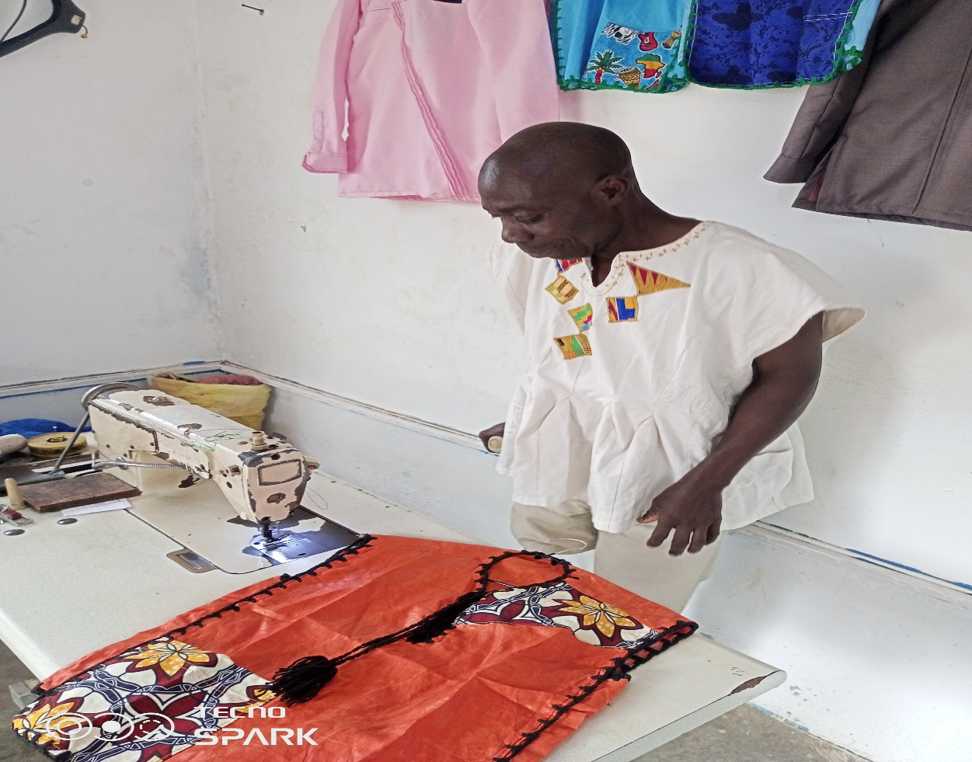
Figure 1a PWD from Bawijiase who received a sewing machine from the District Assembly.

7. DIGNITARIES Present
The event was attended by key stakeholders including:
- Mr. M. Benjamin Narh, District Social Welfare Officer
- Hon. Moses Ahinfu-Acquah, District Chief Executive
The DCE, Hon. Moses Ahinfu-Acquah, addressed the gathering and used the opportunity to counsel the beneficiaries on the importance of maintaining the tools and using them productively. He emphasized the need for discipline, accountability, and entrepreneurial spirit among beneficiaries to ensure the long-term benefits of the support received.

8. CONCLUSION
The distribution of working tools to PWDs in the Awutu Senya District marks another milestone in the Assembly’s commitment to promoting inclusive development and supporting vulnerable groups. It is expected that the beneficiaries will use the tools received to improve their livelihoods and contribute meaningfully to their communities.

Prepared by:
M. Benjamin Narh.

