REPORT ON PRESENTATION OF INCOME-GENERATING ITEMS TO PERSONS WITH DISABILITY BY THE AWUTU SENYA DISTRICT ASSEMBLYDate of Event: 31st December 2024

Venue: Awutu Senya District Assembly Premises

Organized by: Awutu Senya District Assembly

Facilitated by: Department of Social Welfare

INTRODUCTION

On Tuesday, 31st December 2024, the Awutu Senya District Assembly held a special ceremony to present income-generating items to forty (40) selected Persons With Disability (PWDs) from various communities within the district. The initiative is in line with the government's commitment to empowering PWDs economically and promoting inclusive development across all sectors of society.
BENEFICIARIES AND DISTRIBUTION
The recipients were selected from the following communities:
- Awutu Bontrase
- Awutu Beraku
- Simpapebiso
- Obaakwei
- Obrachire Brebianiha
- Bawjiase
GENDER BREAKDOWN:
- Male: 15
- Female: 25

ITEMS DISTRIBUTED:
Item | Quantity | Number of Beneficiaries
Fufu Pounding Machines | 5 | 5
Industrial Sewing Machines | 5 | 5
Laptops | 4 | 4
Chest Freezers | 25 | 25
Wheelchair | 1 | 1
Each item was carefully matched to the individual’s expressed area of interest, skill set, or business initiative, following needs assessment and recommendations from the Department of Social Welfare.

PURPOSE OF THE INTERVENTION
This initiative aims to:
- Promote economic self-reliance among Persons With Disability.
- Reduce dependency on family or community.
- Foster inclusion and equal participation in local economic activities.
- Support education and vocational skills among PWDs.
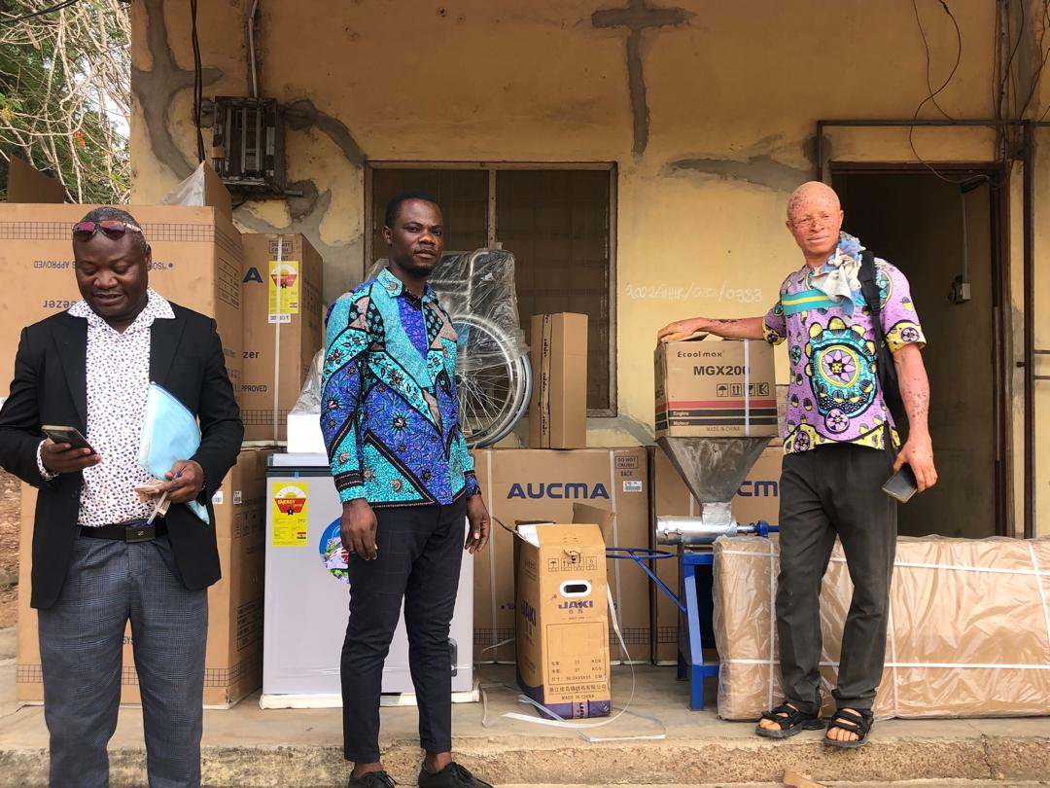
Figure 1social welfare Officers and the GFD President(extreme righ) getting ready to present items to Person With Disaabilities.

KEY SPEAKERS
SPEECH BY THE ADMINISTRATOR OF THE DISTRICT ASSEMBLY.
The Administrator of the Awutu Senya District Assembly representing the District Coordinating Director addressed the beneficiaries in a cordial and informal fashion. He noted that the District Assembly has made immense efforts at building an inclusive and empowered society of Persons With Disabilities in the district. He stated that actors of the government at the district level believe that Persons With Disability just like any group of people can be very productive when given the right resources and supported. Thus the Awutu Senya District Assembly with such mindset has been committed to supporting Persons With Disability over the years and will even do more in the coming years.

SPEECH BY THE DISTRICT SOCIAL WELFARE OFFICER ,
Mr. M. Benjamin Narh, the District Social Welfare Office expressed his happiness of witnessing continual support of Persons With Disability by the Awutu Senyan District Assembly. The stated that the Department of Social Welfare, believe in the potential of the vulnerable groupings in society especially Persons With Disability. He disclosed that the Awutu Senya District Assembly remains focus in creating the enabling environment for all vulnerable persons to explore their developmental potential. He maintained that the selection of Persons With Disabilities for this income-generating items presentation are a result of careful assessments and a dedication to social protection.

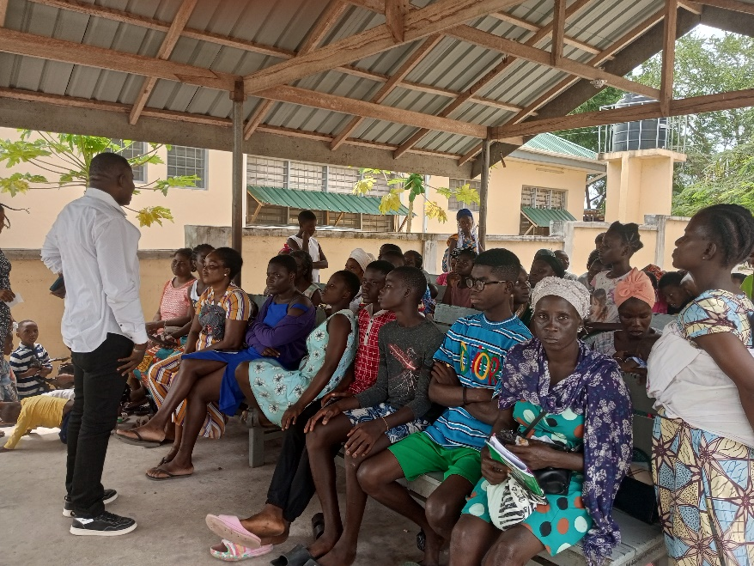
Figure 2a staff of the Department addressins a section of the PWD beneficiaries.

TESTIMONIALS AND REACTIONS
Some beneficiaries expressed gratitude and pledged to put the items to productive use. A young woman from Bawjiase who received a chest freezer stated that it would allow her to start her frozen food business, while another recipient who received a laptop shared aspirations to pursue an online digital marketing course.
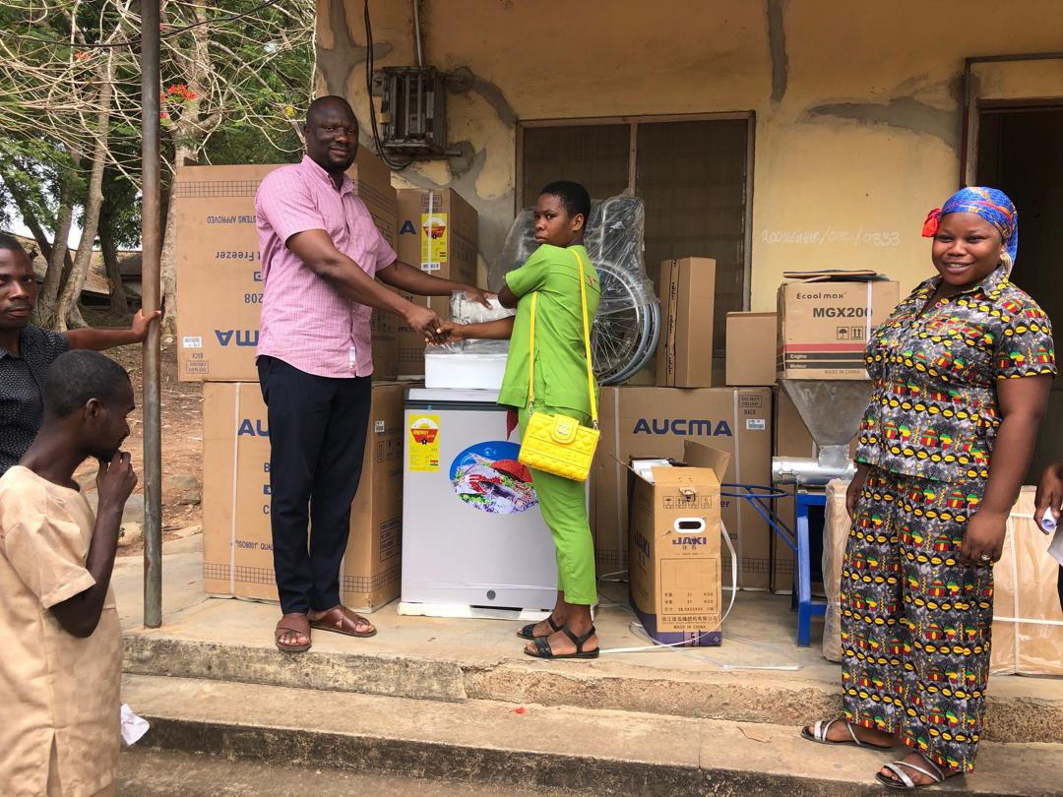
Figure 3head of Administrators of the Awutu Senya presenting some of the income generating items to beneficiary PWDs.

MONITORING AND EVALUATION
The District Assembly, in collaboration with the Department of Social Welfare, will conduct follow-up visits every quarter to:
- Assess usage of the equipment.
- Offer technical and business advisory services.
- Identify further training or capital needs.

CONCLUSION
The event was a success, marking a step forward in inclusive economic empowerment within the Awutu Senya District. It reflects the District Assembly’s ongoing commitment to ensuring that no one is left behind in the development process.

Prepared by:
M. Benjamin Narh
(Head of Social Welfare Unit)

