REPORT ON THE PRESENTATION OF WORKING TOOLS TO PERSONS WITH DISABILITY BY THE AWUTU SENYA DISTRICT ASSEMBLY
Date of Event: Monday, 19th August, 2024
Venue: Awutu Senya District Assembly Premises

1. INTRODUCTION
On Monday, 19th August 2024, the Awutu Senya District Assembly held a formal presentation ceremony to distribute various working tools to forty (40) persons with disability across the district. This initiative forms part of the Assembly’s ongoing efforts to empower persons with disability (PWDs) economically and socially through the utilization of the District Assemblies Common Fund for Persons with Disability (DACF-PWD).

2. ITEMS DISTRIBUTED
A total of forty working items and one(1) wheel chair were distributed.
- Popcorn Machines – 10 beneficiaries
- Chest Freezers – 30 beneficiaries
- Wheelchair – 1 male beneficiary

3. GENDER DISTRIBUTION OF BENEFICIARIES
The beneficiaries consisted of:
- 19 Females
- 22 Males
It is noteworthy that the only wheelchair donated was given to a male beneficiary.

4. REMARKS BY THE DISTRICT CHIEF EXECUTIVE (DCE)
Mr. Moses Arhinful-Acquah, the District Chief Executive, addressed the beneficiaries and emphasized the following key points:
- The distributed items represent the government’s support to enhance the economic lives of PWDs.
- Beneficiaries were urged to maintain the tools properly and use them for their intended purposes.
- The DCE reminded them that the viability and sustainability of the support largely depends on the seriousness and commitment of the beneficiaries.
- He encouraged the recipients to embrace this opportunity with responsibility and diligence.

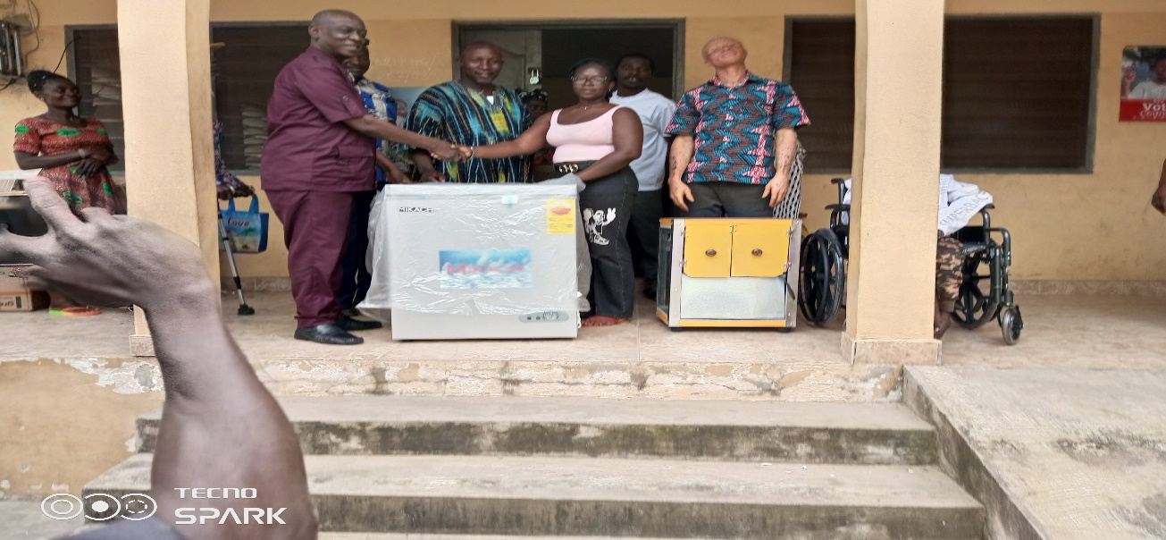
Figure 1District Chief Executive, Hon. Moses Arhinful-Acquah presenting working tools to PWD beneficiaries.

5. REMARKS BY THE DISTRICT SOCIAL WELFARE OFFICER
The District Social Welfare Officer also addressed the gathering. Highlights of his remarks included:
- A word of appreciation to the beneficiaries for availing themselves for the support programme.
- Awareness creation on the Disability Fund, which is credited to the Assembly’s account on a quarterly basis.
- Emphasis on the judicious use of the working tools provided.
- He mentioned that in future when the beneficiaries apply for another assistance from the District Assembly, the Department of Social Welfare and Community Development will assess how well each beneficiary utilized the items previously received.
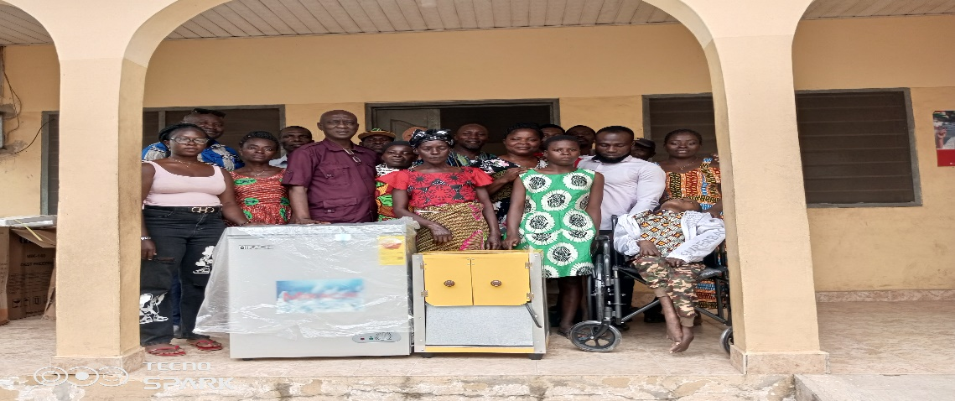
Figure 2 some beneficiaries with the DCE

6. COMMUNITIES Represented
The beneficiaries were drawn from the following communities within the Awutu Senya District:
- Adewukwa
- Mfanf
- Ayensuako
- Beraku
- Simpapebiso
- Afajator
- Ndadetor
- Bawjiase
- Mayenda
- Nyarkokwa
- Awutu Brebianiha

7. LIST OF BENEFICIARIES
- Esther Dompreh
- Essel K. Ewusi
- Gladys Esel
- Stephen K. Otoo
- Efua Menamatsen
- Samuel Amo
- Abigail Tettsie
- George K. Bartels
- Esther Pobie
- James Opare
- Seth Botwey
- Philip Oguan
- Chris Boateng
- Sarah Appiah
- Jefferine Tetteh
- Ransford Tetteh
- Ama Amoquando
- Emmanuel Aidoo
- Cecelia Sarkyire
- Felix Obiri
- Grace Quaye
- Mary Okai
- Mary Saaye
- Grace Okai
- Comfort Abbey
- Emmanuel Parbie
- Janet Okyere
- Ebenezer Aidoo
- Abraham Acheampong
- Emmanuel Quaye
- Kweku Odai
- Tenny Emmanuel
- Oforiwa Linda
- James Koomson
- Mavis Barnes
- Nicholas Afful
- Naomi Ofori
- Quaye Christabel
- Joyce Adjei
- Aklasu Nora

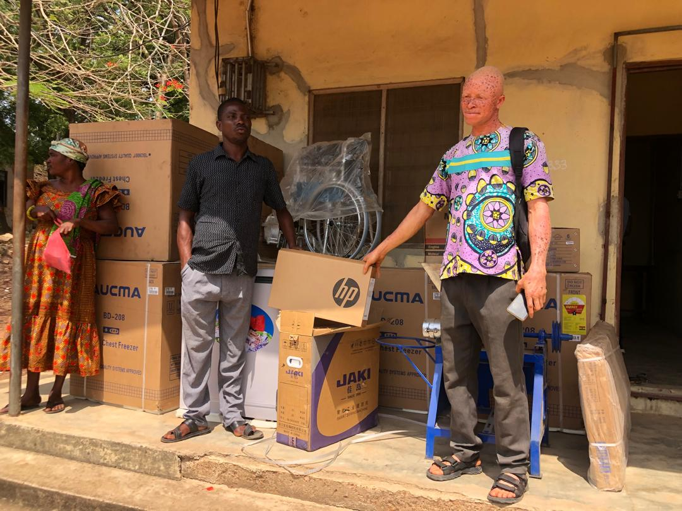
Figure 3GFD Exeutives displaying some items to be presented to the PWD beneficiaries.

8. CONCLUSION
The presentation ceremony marked yet another milestone in the District Assembly’s commitment to inclusive development and economic empowerment for persons with disability. The event was successful, with all fort-One(41) items handed over to the respective beneficiaries. The Assembly urges all beneficiaries to make the most of this opportunity to improve their livelihoods and serve as examples for future support programmes.

Signed:
M. Benjamin Narh
[Head of Social Welfare Unit)
Awutu Senya District Assembly.

