PUBLIC EDUCATION CAMPAIGN ON GUN AMNESTY ENDS IN AWUTU SENYA DISTRICT ASSEMBLY
Report by ISD, ASDA
The Information Services Department in Awutu Senya District Assembly has carried out a three-day Public Education Campaign on Gun Amnesty Programme in the district beginning from Wednesday, 28th January 2026 to Friday, 30th January 2026.

The Gun Amnesty Programme which begun from 1st December 2025 to 30th January 2026 allows individuals in possession of unregistered or illicit firearms to surrender them voluntarily to the nearest District Police Station without fear of questioning, arrest or prosecution. The surrendered weapons will be destroyed safely to reduce the number of illicit firearms in circulation.

Refusing to surrender illegal, unlicensed or prohibited firearms after the amnesty period will result in severe legal consequences, including arrest, prosecution and a prison sentences up to about 10 years.

Reports from the Ghana Police Service and the Research Unit of the National Commission on Small Arms and Light Weapons indicate that large quantities of weapons are suspected to be in the hands of civilians with many smuggled into the country through the ports and land borders.
According to the report from the Ghana Police Service, the increasing misuse of these illicit gun circulation in the country is contributing to disturbing rise in gun related violence from armed robbery to tragic incidents at traditional and cultural events.

It is upon this background that the Government of Ghana through the Ministry of Interior in collaboration with the Ghana Police Service and the National Commission on Small Arms and Light Weapons has implemented a Gun Amnesty Programme (GAP) in the country to run from 1st December 2025 to 30th January 2026.

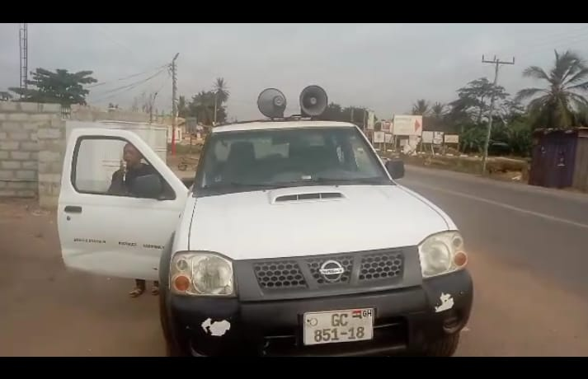
Van Outreach on Gun Amnesty at Bawjiase
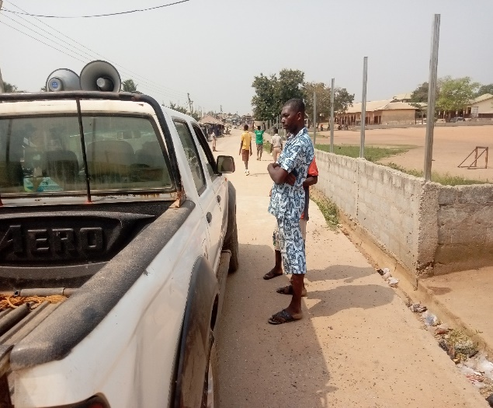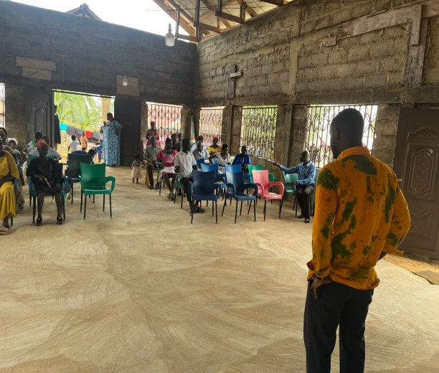
Van Outreach at Bereku Community Engement at Choechoe

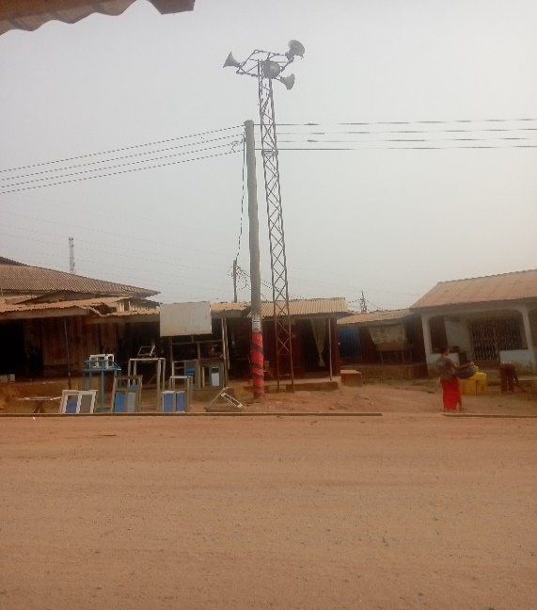
CIC Sensitization at Bonsuoku CIC Sensitization at Senya

