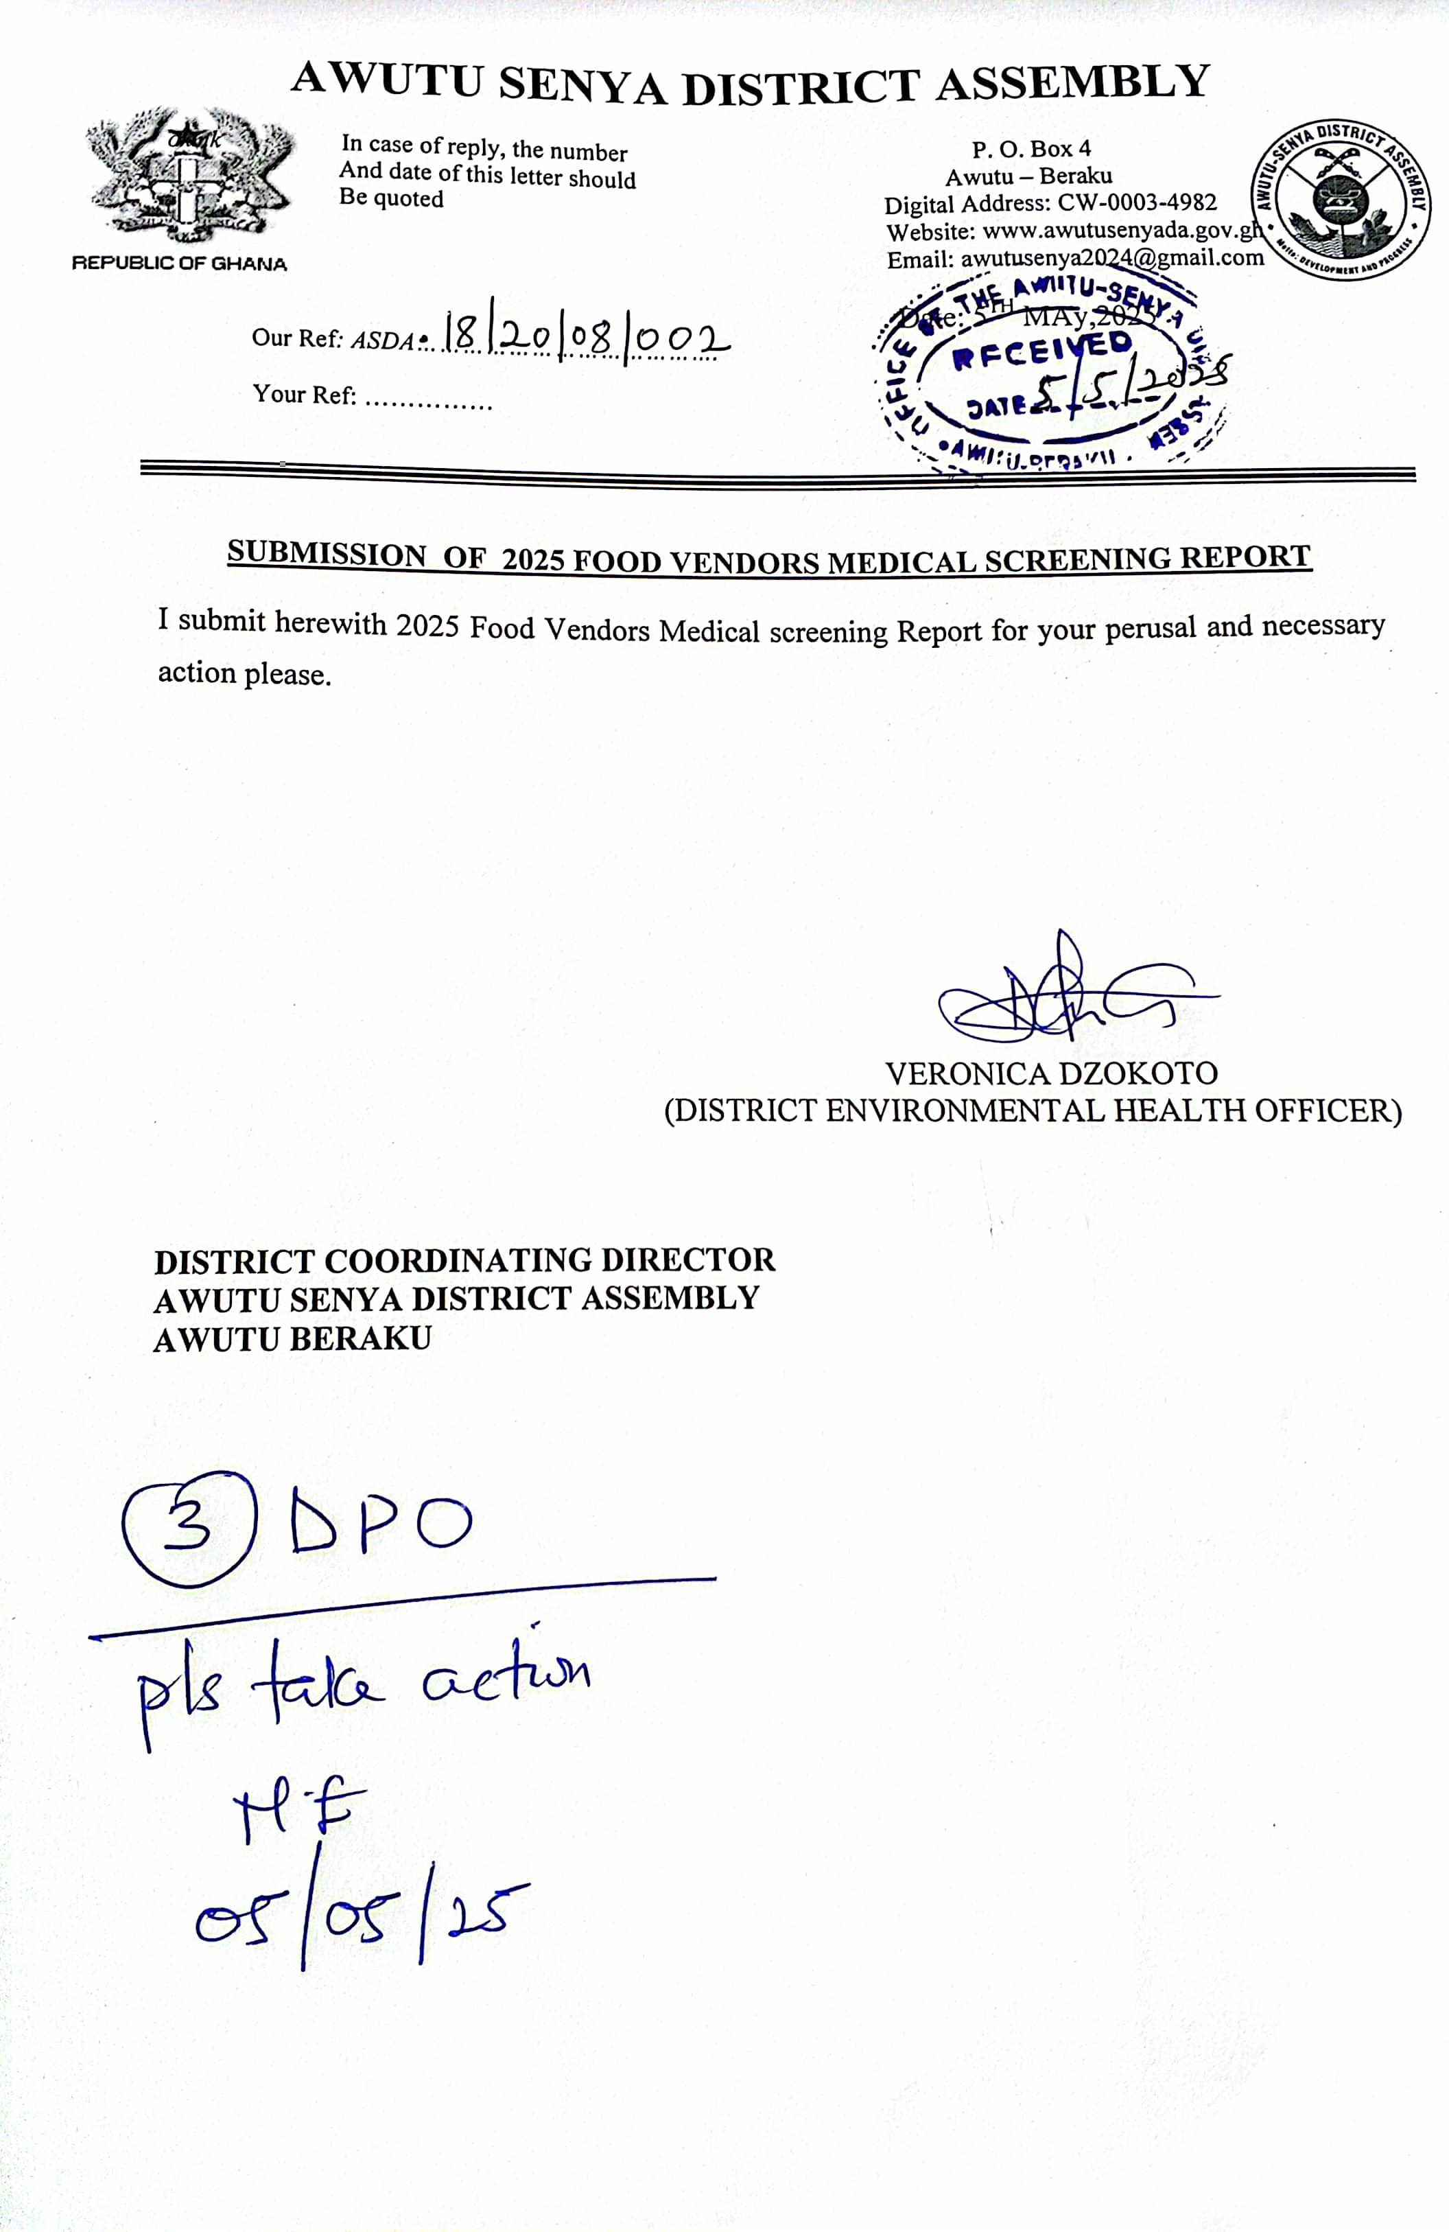


AWUTU SENYA DISTRICT ASSEMBLY

ENVIRONMENTAL

HEALTH AND SANITATION UNIT

SENSITIZATION AND MEDICAL
SCREENING OF FOOD VENDORS AND
HANDLERS AT AWUTU SENYA DISTRICT
-
MAY,2025

CONTENTS
LIST OF TABLES 3
EXECUTIVE SUMMARY 4
1.0INTRODUCTION 5
1.1Background 5
1.2Objectives 5
1.3Target Group 5
2.0METHODS 6
2.1Memorandum of Understanding (MoU)signed 6
2.2Human Resource for the exercise 6
2.3 Publicity and mobilization 6
2.4Laboratory Investigations 7
3.0OUTCOME OF THE EXERCISE 8
3.1Observations/Findings/Remarks 8
3.1.1Number of vendors screened 8

3.1.2Laboratory Results ....................................................................................................... 8
3.1.4Financial appropriation ................................................................................................ 4
4.0CONCLUSION AND RECOMMENDATIONS ....................................................................... 5
4.1Conclusion .......................................................................................................................... 5
4.2 Recommendations .............................................................................................................. 5
GALLERIES .............................................................................................................................. 6

LIST OF TABLES
Table 1:Zonal Areas ................................................................................................................... 6
Table 2:Number of Vendors screened .......................................................................................... 8
Table 3:Distribution by gender .................................................................................................... 8
Table 4: Distributions by Food Vending operations ...................................................................... 9
Table 5:Distribution by Food vending operations ......................................................................... 1
Table 6:Laboratory Results from Area Councils .......................................................................... 1
Table 7:Distribution of positive cases by Zonal Areas ................................................................... 2
Table 8:Financial appropriation .................................................................................................. 4

LIST OF FIGURES
Figure 1:Distribution by gender .................................................................................................. 9
Figure 2: Food vending operations in the District ......................................................................... 9
Figure 3:Number of Positive cases in the Area Councils ............................................................... 1

EXECUTIVE SUMMARY
As part of this year activities of promoting health and hygiene within the district for medical fitness, the Environmental Health and Sanitation Unit under the Auspices of Awutu Senya District Assembly embarked on a Mass Medical Screening and Health Education for all Food and Drink Handlers in the Awutu Senya District Assembly from Monday 17th March,2025 to 18th April,2025. The objective of the exercise was to avert the transmission of communicable infectious diseases such as typhoid fever, cholera, tuberculosis, hepatitis, dysentery etc. within the district specifically
- To educate Five Thousand (5,000) Food and Drink Handlers by 30th April,2025
- To conduct Medical Laboratory Screening and counselling for Thousand (5,000) Food and Drink Handlers by 30th April,2025.
- To certify Five Thousand (5,000) Food and Drink Handlers by 30th April,2025
- To compile data of results and come up with recommendation for future health promotion of Food and Drink Handlers.
At the end of the exercise, the following outcomes were observed; One Thousand Nine Hundred and Eight (1,908) Food and Drink Handlers were fully educated and were willing to be medically screened and certified, One Thousand Nine Hundred and Six (1,908) Food and Drink Handlers were medically screened presenting 38.16%. After the laboratory confirmation of results, all participants were denied certificate and were directed to undergo medical treatment after which they will be certified. It is recommended that the Environmental Health and Sanitation Unit of the District Assembly should ensure that all Food and Drink Handlers who are not medically screened and certified are not allowed to operate in the district to prevent spread of diseases

1.0INTRODUCTION

1.1Background
To ensure that the general public is safe, free from food poisoning, food contamination, sale of unwholesome foods, sale of expired products for human consumption within Awutu Senya District. The office under Awutu Senya District Assembly responsible for ensuring that contaminated food and products, expired products such as drugs, bottled and sachet water and provisions are not sold to the general public. Every year, the office has the mandate to ensure that all Food and Drink handlers are medically screened and certified before selling out food and drinks to the general public which is in line with Public Health Act (Act851) which criminalizes the sale of unwholesome food or drink without Medical Certificate of fitness.
As part of this year activities of promoting health and hygiene within the district for medical fitness, the Environmental Health and Sanitation Unit under the Auspices of Awutu Senya District Assembly and MSSR Nyamekye Consult embarked on a Mass Medical Screening and Health Education for all Food and Drink Handlers in the Awutu Senya District Assembly from Monday 17th March,2025 to 18th April,2025.

1.2Objectives
The objective of the exercise was to avert the transmission of communicable infectious diseases such as typhoid fever, cholera, tuberculosis, hepatitis, dysentery etc. within the district specifically
- To educate Five Thousand (5,000) Food and Drink Handlers by 30th April,2025
- To conduct Medical Laboratory Screening and counselling for Thousand (5,000) Food and Drink Handlers by 30th April,2025.
- To certify at least 90% Food and Drink Handlers medically screened by 30th April,2025
- To compile data of results and come up with recommendation for future health promotion of Food and Drink Handlers.

1.3Target Group
Target group of people who were screened include Sachet water producers, distributors and retailers, Alcoholic and soft drinks manufacturers and distributors and retailers, restaurants, chop bar and joint food operators, hotels, pub food and drink handlers,fufu,pepper,tomatoes sellers, corn millers,backery and fryers,butchers,barbecue and kebab sellers, fried yam and rice sellers, cooked and mashed kenkey sellers, cold store operators, Fish mongers and fryers, Drinking Bar Operators, Provision store operators and Institutional Canteen Staff etc. All these people were targeted to screened and most of them were screened.

2.0METHODS

2.1Memorandum of Understanding (MoU)signed
Before the inception of the exercise, there was an agreement signed between the Management of the Assembly and the Contractor. It was stated in the agreement that the contractor will use his logistics such as information van and fuel to mobilize the participants for the exercise and also equipment and test kits for the test. Again, it was agreed that the money that will be accrued, the contractor should receive 52% of it for the work done and part of it should go to the Assembly and the Environmental Health Officer who maned the exercise.

2.2Human Resource for the exercise
A team of qualified medical doctors, nurses, biomedical scientists, public health personnel and other staff were employed to undertake the medical screening exercise.

2.3 Publicity and mobilization
Before the commencement of the programme, awareness was fully created through the various community information centers, churches, and home visit session by the Environmental Health Officers in collaboration with Nyamekye Medical Consult.
2.4 Zoning of Area Council for the exercise
For efficient work done, all the Area Councils were zoned and medical screening centers were created for each zonal area so that every food vendor can be captured in the exercise. Below is the zonal areas for the Area Councils.

Table 1:Zonal Areas
S/N | AREA COUNCILS | NUMBER  AREAS | OF | ZONAL
1 | Awutu | 6
2 | Bawjiase | 4
3 | Bontrase | 2
4 | Jei-Krodua | 10
5 | Obrachire | 4
6 | Senya | 5
 | Total | 31

2.4Laboratory Investigations
All the participants were made to undergo the following laboratory investigation to medically screen them.
• Blood samples collected for Typhoid fever test

3.0OUTCOME OF THE EXERCISE

3.1Observations/Findings/Remarks

3.1.1Number of vendors screened
A total of One Thousand Nine Hundred and Eight (1,908) were screened across the Six Area Councils. Below is the breakdown
Table 2:Number of Vendors screened
S/N | AREA COUNCIL | TARGET | NUMBER OF  FOOD VENDORS SCREENED | % ACHIEVED
1 | Senya | 1,000 | 364 | 36.40%
2 | Beraku | 1,000 | 491 | 49.10%
3 | Obrachire | 300 | 120 | 40.00%
4 | Bontrase | 400 | 153 | 38.25%
5 | Bawjiase | 1,500 | 406 | 27.07%
6 | Jei-Krodua | 800 | 374 | 46.75%
 | Total | 5,000 | 1,908 | 38.16%

3.1.2 Distribution by gender
A total of One Hundred and Twenty-Seven males undergone the Food vendors medical screening exercise which represents 6.66% of the total food vendors screened

Table 3:Distribution by gender
S/N |  | GENDER | TOTAL | PROPORTIONS (%)
1 | Males |  | 127 | 6.66%
2 | Females |  | 1,781 | 93.34%
Total |  |  | 1,908 | 100%



127

1781

Distribution bygender

male
females

Figure 1:Distribution by gender Table 4: Distributions by Food Vending operations
S/N | AREA  COUNCILS | FOOD | PROVISION | DRINKS/  WATER | FISH/MEAT/  COLD  STORE | FOODSTUFFS/  FRUITS/  VEGETABLES | BREAD/  PASTERIES  BAKERIES
1 | Senya | 185 | 70 | 50 | 25 | 18 | 16
2 | Awutu | 261 | 106 | 45 | 34 | 25 | 20
3 | Bontrase | 81 | 32 | 16 | 11 | 4 | 9
4 | Bawjiase | 226 | 57 | 37 | 29 | 21 | 36
5 | Jei-Krodua | 221 | 82 | 42 | 13 | 4 | 12
6 | Obrachire | 85 | 20 | 6 | 6 | 0 | 3
Total |  | 1,059 | 367 | 196 | 118 | 72 | 96

FOOD VENDING OPERATIONS IN THE
DISTRICT

FOOD
PROVISION
DRINKS/WATER
FISH/MEAT/COLDSTORES
FOOD STUFFS/FRUITS/VEGETABLES
BREAD/PASTERIES/BAKERIES
Figure 2: Food vending operations in the District

3.1.4Distributions by Food vending operations with proportions
The food vendors who were screened were categorized according the type of operations they undertake and these are Food, Provisions, Drinks/ Water, Fish /Meat/ Cold stores, Foodstuffs/ Fruits/ Vegetables and Bread/ Pasteries/Bakeries.Below is the breakdown Table 5:Distribution by Food vending operations with proportions
S/N | AREA COUNCILS | FOOD |  | PROVISION |  | DRINKS/WATER |  | FISH/  MEAT/  COLD STORES |  | FOODSTUFFS  /FRUITS/  VEGETABLES |  | BREAD/  PASTERIES/  BAKERIES |  | TOTAL
S/N | AREA COUNCILS | NUMBER | PROPO  RTION  (%) | NUMBER | PROPOR  TION  (%) | NUMBER | PROPOR  TION  (%) | NUMBER | PROPOR  TION  (%) | NUMBER | PROPOR  TION  (%) | NUMBER | PROPOR  TION  (%) | TOTAL
1 | Senya | 185 | 50.82% | 70 | 19.23% | 50 | 13.74% | 25 | 6.87% | 18 | 4.95% | 16 | 4.40% | 364
2 | Awutu | 261 | 53.16% | 106 | 21.59% | 45 | 9.16% | 34 | 6.92% | 25 | 5.09% | 20 | 4.07% | 491
3 | Bontrase | 81 | 52.94% | 32 | 20.92% | 16 | 10.46% | 11 | 7.19% | 4 | 2.61% | 9 | 5.88% | 153
4 | Bawjiase | 226 | 55.67% | 57 | 14.04% | 37 | 9.11% | 29 | 7.14% | 21 | 5.17% | 36 | 8.87% | 406
5 | Jei-Krodua | 221 | 59.09% | 82 | 21.93% | 42 | 11.23% | 13 | 3.48% | 4 | 1.07% | 12 | 3.21% | 374
6 | Obrachire | 85 | 70.83% | 20 | 16.67% | 6 | 5.00% | 6 | 5.00% | 0 | 0.00% | 3 | 2.50% | 120
Tota | l | 1,059 | 55.50% | 367 | 19.23% | 196 | 10.27% | 118 | 6.18% | 72 | 3.77% | 96 | 5.03% | 1908

1 | P a g e

Laboratory Results
After the medical screening, a total of One Hundred and Fifty-Four (154) Food vendors were typhoid fever positives representing 8.07% of the total number of screened Food vendors. Table 6:Laboratory Results from Area Councils
S/N | AREA COUNCIL | POSITIVE CASES |  | POSITIVE CASES |  | TOTAL
S/N | AREA COUNCIL | NUMBER | PROPORTION (%) | NUMBER | PROPORTION (%) | TOTAL
1 | Awutu | 12 | 2.44% | 479 | 97.56% | 491
2 | Bawjiase | 45 | 11.08% | 361 | 88.92% | 406
3 | Bontrase | 27 | 17.65% | 126 | 82.35% | 153
4 | Jei-Krodua | 24 | 6.42% | 350 | 93.58% | 374
5 | Obrachire | 15 | 12.50% | 105 | 87.50% | 120
6 | Senya | 31 | 8.52% | 333 | 91.48% | 364
TOTAL |  | 154 | 8.07% | 1754 | 91.93% | 1908



12

45

27

24

15

31

AWUTU
BAWJIASE
BONTRASE
JEI-KRODUA
OBRACHIRE
SENYA
NUMBER POSITIVE CASES IN AREA
COUNCILS

Figure 3:Number of Positive cases in the Area Councils

- | P a g e

Table 7:Distribution of positive cases by Zonal Areas
S/N | AREA COUNCILS | ZONAL AREAS | POSITIVE CASES |  | NEGATIVE CASES |  | TOTAL
S/N | AREA COUNCILS | ZONAL AREAS | NUMBER | (%) | NUMBER | (%) | TOTAL
1 | Awutu | Durbar Grounds | 9 | 4.31% | 200 | 95.69% | 209
2 | Awutu | D/A Basic School | 3 | 6.98% | 40 | 93.02% | 43
3 | Awutu | Akrampa Junction | 0 | 0.00% | 97 | 100% | 97
4 | Awutu | St Kelian School | 0 | 0.00% | 97 | 100% | 97
5 | Awutu | Choechoe | 0 | 0.00% | 26 | 100% | 26
6 | Awutu | Ahentia | 0 | 0.00% | 29 | 100% | 29
7 | Bawjiase | Station | 12 | 8.57% | 128 | 9.43% | 140
8 | Bawjiase | SDA School | 14 | 25.00 | 42 | 75.00% | 56
9 | Bawjiase | Methodist School | 10 | 9.17% | 99 | 90.83% | 109
10 | Bawjiase | Adom Clinic Park | 9 | 8.91% | 92 | 91.09% | 101
11 | Bontrase | Area Council Office | 9 | 11.11% | 72 | 88.99% | 81
12 | Bontrase | D/A Primary School | 18 | 25 | 54 | 75.00% | 72
13 | Jei-Krodua | Jei-Krodua | 7 | 11.11% | 53 | 88.99% | 60
14 | Jei-Krodua | Adawukwa | 8 | 16.00% | 42 | 84.00% | 50
15 | Jei-Krodua | Akuffo-Krodua | 0 | 0.00% | 21 | 100% | 21
16 | Jei-Krodua | Afadzator | 0 | 0.00% | 18 | 100% | 18
17 | Jei-Krodua | Mankomeda | 0 | 0.00% | 23 | 100% | 23
18 | Jei-Krodua | Yamoah Nkwanta | 9 | 23.68% | 29 | 76.32% | 38
19 | Jei-Krodua | Papaase No.2 | 0 | 0.00% | 58 | 100% | 58
20 | Jei-Krodua | Papaase No.1 | 0 | 0.00% | 40 | 100% | 40
21 | Jei-Krodua | Kwao-Bondzie | 0 | 0.00% | 31 | 100% | 31
22 | Jei-Krodua | Oklu Nkwanta | 0 | 0.00% | 35 | 100% | 35
23 | Obrachire | Obrachire | 12 | 17.91% | 55 | 82.19% | 67
24 | Obrachire | Akropong | 1 | 5.88% | 16 | 84.12% | 17
25 | Obrachire | Bibianiha | 1 | 4.17% | 23 | 85.83% | 24
26 | Obrachire | Mfafo | 1 | 8.33% | 11 | 81.67% | 12
27 | Senya | Main Office | 14 | 9.15% | 139 | 80.85% | 153
28 | Senya | Cold store | 8 | 9.41% | 77 | 80.59% | 85
29 | Senya | Roman School | 1 | 2.00% | 49 | 98.00% | 50
30 | Senya | Castle | 2 | 7.69% | 24 | 82.31% | 26
31 | Senya | Bonsuoku | 6 | 12.00% | 44 | 88.00% | 50

- | P a g e

3.1.6Review of results and action taken
After the medical screening, all the results were thoroughly reviewed and the following steps were taken
- Most of the Food Vendors who were medically fit were issued with Medical Certificate
- Some of the Food Vendors who had traces of typhoid Bacteria in their blood were though issued with Medical Certificate but cautioned to treat the typhoid within two weeks, otherwise stop from operation.
- All the Food Vendors who had high typhoid bacteria in their blood were not issued with medical Certificate and stopped from operation until treatment and further typhoid test proves negative.
- After the medical screening exercise, all the Food Vendors who were reported with high typhoid bacteria were stopped from operation were monitored to ensure that they undergo medical treatment.

3.2General Observations and remarks
The medical screening exercise recorded low participation due to the following reasons
- The publicity for the exercise was not effective and efficient because the contractor was not ready to put in more financial resources.
- The contractor did not have Task force to enforce and mobilize food vendors to come to the designated places of the exercise for participation.
- The contractor did not listern to the suggestions given to him by the Environmental Health Officers.

3 | P a g e

3.1.4Financial appropriation
Before the commencement of the exercise, each participant was charged Forty Ghana Cedis (GH₵ 50.00). At the end of the exercise, One Thousand Nine Hundred and Eight (1,908) Food Vendors were fully screened and hence Ninety-Five Thousand Four Hundred Ghana Cedis (GH₵ 95,400). Below is the financial appropriation Table 8:Financial appropriation
S/N | AREA  COUNCIL | NUMBER  OFPEOPLE  SCREENED | AMOUNT  ACRUED  (GH₵) | CONTRACTOR  SHARE  (52.00%) | ASSEMBLY  ACCOUNT (20.00%) | MANAGEMENT  OF ASSEMBLY  (20.00%) | ENVIRONMENTAL  HEALTH OFFICERS  (8.00%)
1 | Awutu | 491 | 24,550.00 | 12,766.00 | 4,910.00 | 4,910.00 | 1,964.00
2 | Bawjiase | 406 | 20,300.00 | 10,556.00 | 4,060.00 | 4,060.00 | 1,624.00
3 | Bontrase | 153 | 7,650.00 | 3,978.00 | 1,530.00 | 1,530.00 | 612.00
4 | Jei-Krodua | 374 | 18,700.00 | 9,724.00 | 3,740.00 | 3,740.00 | 1,496.00
5 | Obrachire | 120 | 6000.00 | 3,120.00 | 1,200.00 | 1,200.00 | 480.00
6 | Senya | 364 | 18,200.00 | 9,464.00 | 3,640.00 | 3,640.00 | 1,456.00
Total |  | 1,908 | 95400.00 | 49,608.00 | 19,080.00 | 19,080.00 | 7,632.00

4 | P a g e

4.0CONCLUSION AND RECOMMENDATIONS 4.1Conclusion To educate Five Thousand (5,000) Food and Drink Handlers by 30th April,202
One Thousand Nine Hundred and Eight (1,908) Food and Drink Handlers were fully educated and were willing to be medically screened and certified.
To conduct Medical Laboratory Screening and counseling for Five Thousand (5,000) Food and Drink Handlers by 30th April,2025
One Thousand Nine Hundred and Eight (1,908) Food and Drink Handlers were medically screened
To certify Five Thousand (5000) Food and Drink Handlers by 30th April,2025
After the medical screening, One Thousand Seven Hundred and Fifty-Four (1,754) presenting 91.93% of the total number of medically screened Food and Drink Handlers were medically fit to be issued with Food vendors’ certificate.

To compile data of results and come up with recommendation for future health promotion of Food and Drink Handlers.
After the laboratory confirmation of results, all participants were denied certificate and were directed to undergo medical treatment after which they will be certified.

4.2 Recommendations
- The District Assembly should not give any contract to the contractor again following his abysmal performance in the 2025 Food vendor medical screening exercise for the district.
- The District Assembly should contract another entity to undertake mop-up medical screening exercise since the chunk of food vendors were not screened and are selling food for public consumption.
- The Environmental Health and Sanitation Unit of the District Assembly should ensure that all Food and Drink Handlers who are not medically screened and certified are not allowed to operate in the district to prevent spread of diseases.

GALLERIES
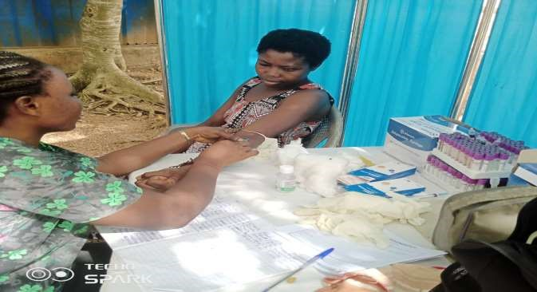
Food Vendors Medical Screening exercise at Awutu Beraku Durbal Ground

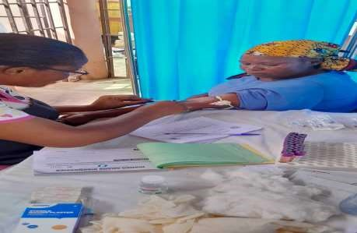
Food Vendors Medical screening exercise at Bawjiase

6 | P a g e

| P a g e

